

**EAST WEST UNIVERSITY**

**Project Report**

**Course Code:** CSE479

**Course Title:** Web Programming

**Section:** 04

**Tour & Travel Management**

**Submitted To:**

**Nishat Tasnim Niloy**

**Submitted By:**

|  |  |  |
| --- | --- | --- |
| Serial No. | Name | Student Id |
| 1 | Mahmudul Islam Partho | 2019-3-60-027 |
| 2 | Md. Al Amin | 2019-3-60-016 |
| 3 | Nazia Zaman | 2020-2-60-016 |
| 4 | Meherun Hossain Orpa | 2020-1-60-123 |
| 5 | Nabila Shaeed | 2020-1-60-125 |

**Date of Submission: 7 june, 2024; Friday**

**Project Description**

Our project is all about creating a comprehensive web application to boost tourism. The goal is to provide a platform where users can explore dynamic tour packages, get updates on destinations, and find various promotional offers. Beyond just a travel booking tool, this platform aims to foster cultural exchange, community development, and environmental awareness. By promoting arts and culture, preserving natural heritage, and connecting people socially, we hope to contribute to economic growth and overall well-being.

**Functional Requirements**

1. **User Authentication:**
   * **Sign in**: Allow users to access their accounts securely.
   * **Sign up**: Enable new users to create accounts.
2. **Admin Features:**
   * **Admin Dashboard**: Central control panel for managing content.
   * **Dynamic Tour Package Update**: Admins can add or update tour packages.
   * **Dynamic Offer Update**: Admins can create and modify promotional offers.
   * **Destination Update**: Update and manage destination information.
3. **User Management:**
   * **User Create**: Admins can create user profiles.
   * **Password Change**: Users can update their passwords.

**Non-Functional Requirements**

1. **Performance**:
   * The application should support at least 1000 concurrent users without performance degradation.
2. **Security**:
   * Use HTTPS for secure data transmission and ensure robust authentication mechanisms.
3. **Usability**:
   * The user interface should be intuitive and easy to navigate for all users.
4. **Reliability**:
   * Ensure an uptime of 99.9% to provide a dependable service.

**Diagrams**

* **Use Case Diagram**:

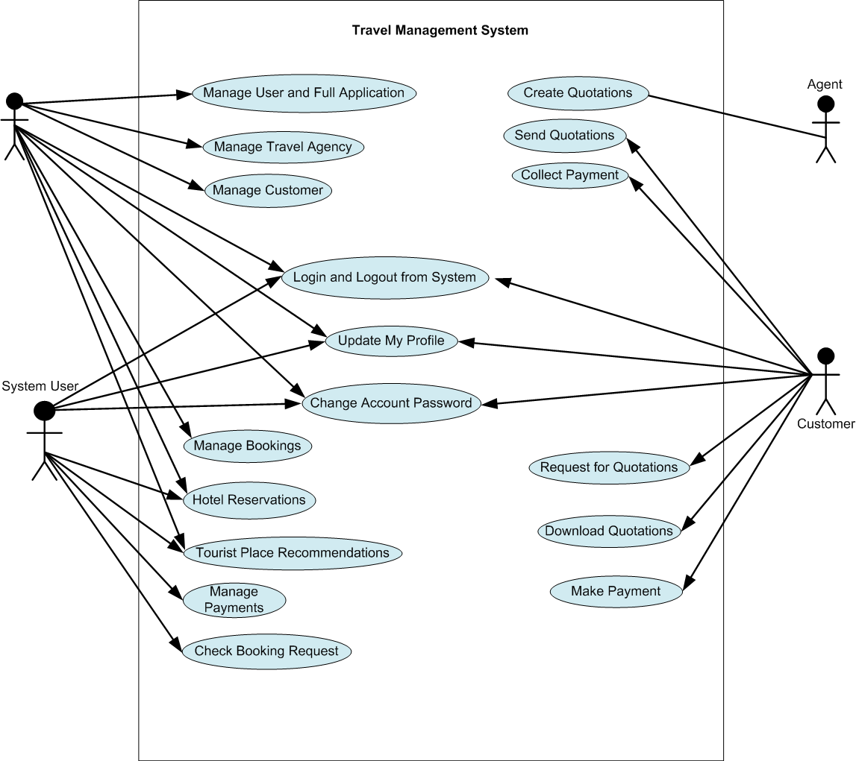

* **ER Diagram**:

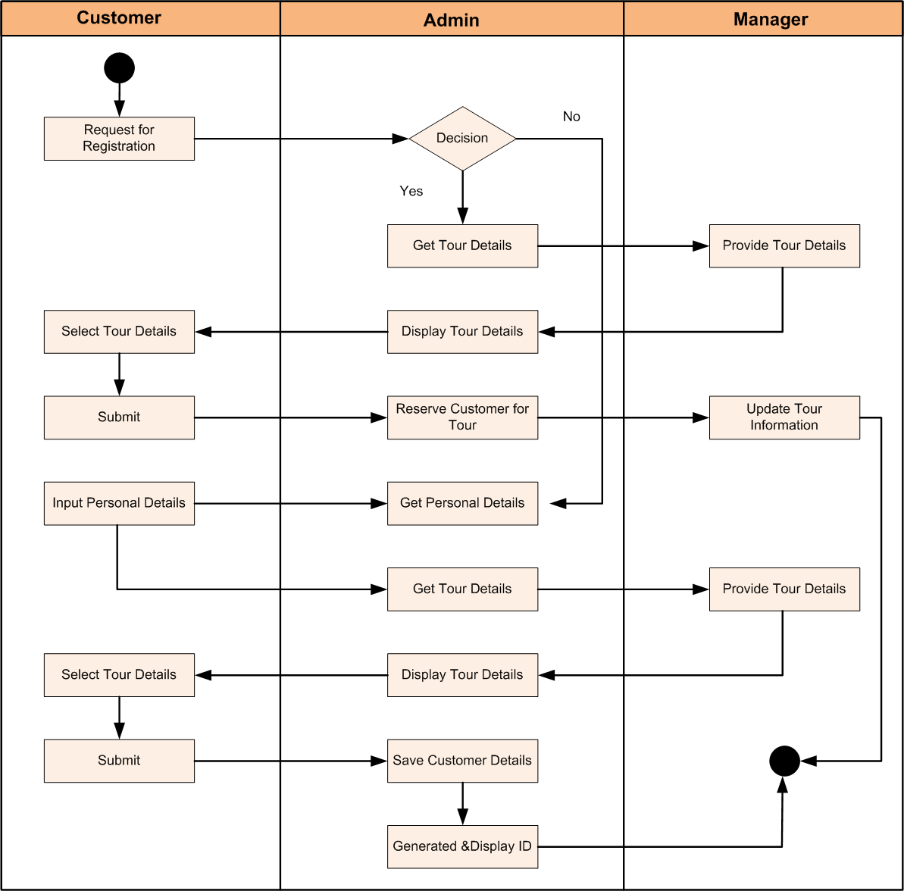

**Group Responsibilities**

* **Mahmudul Islam Partho:** Frontend development, UI/UX design.
* **Md. Al Amin:** Backend development, database management.
* **Nazia Zaman:** API integration, security implementation.
* **Nabila Shaeed:** Content management, admin dashboard functionalities.
* **Meherun Hossain Orpa:** Testing, quality assurance, and deployment.

**Development Timeline**

**Weeks 1 and 2 (Planning the Project and Compiling the Needs):**  
We concentrate on setting the project's foundation throughout the first two weeks. This includes:  
  
**Project Planning:** First, the project's goals, deliverables, and scope are established. This entails drafting an extensive project plan, establishing deadlines, and delegating tasks to each team member.  
  
**Requirements collection:** To collect and record all requirements, we have discussions with stakeholders. Both functional and non-functional requirements are included here (what the application should accomplish) and how the application should operate. To make sure our application satisfies market demands, we carefully investigate and evaluate rivals.

**Weeks 3 and 4 ( UI/UX Design and Frontend Development):**We proceed to the design and development of the application's user interface after having a clear concept and requirements in place:  
  
**UI/UX Design:** With an emphasis on producing a user interface that is both logical and aesthetically pleasing, our designers draft wireframes and mockups for the program. We make sure that every possible user can easily navigate and understand the design.  
  
**Frontend Development:** Our frontend developers begin building the user interface based on the designs. They create responsive and dynamic web sites with technologies including HTML, CSS, and JavaScript. The structure, appearance, and functionality of the application's interface are all created at this phase.

**Weeks 5 and 6 (Database setup and backend development):**  
After the frontend is operational, we move on to the backend:  
 **Backend Development:** The server, database connectivity, and application logic are configured by our backend developers. They develop the main features of the application using programming languages like PHP. This covers data processing, user authentication, and other server-side functions.  
  
**Database Setup:** To effectively store and handle data, we plan and execute the database structure. This entails establishing linkages, tables, and data integrity. We employ database management solutions that best meet the requirements of our application.

**Weeks 7 and 8 (Implementing security and integrating APIs):**After implementing the frontend and backend, we move on to incorporate other features and guarantee the security of the application:  
  
**API Integration:** To improve the functionality of the application, we integrate third-party APIs. Payment gateways, geolocation tools, and social network integrations are a few examples of this. We make sure these APIs integrate and function with our system without a hitch.  
 **Implementation of Security:** Security is of the highest priority. We put security measures in place to guard user information and stop illegal access. Data encryption, safe authentication procedures, and other application security best practices are included in this.

**Weeks 9 and 10 (Quality Control and Testing):**

We must extensively test the application before deploying to make sure everything functions as intended:  
  
**Testing:** We carry out a number of testing procedures, such as system, integration, and unit tests. This aids in finding and resolving any faults or problems with the program.  
  
**Quality Assurance**: To make sure the program is user-friendly and satisfies all standards, our QA team tests its usability. To make sure the program is dependable and effective, they also evaluate its functionality in various scenarios.

**Week 11 (Last-Minute Modifications and Bug Fixes):**  
We concentrate on improving the application over the last week:  
 **Final Changes:** We implement any required changes to the application based on input from testing. This might entail improving functionality, adjusting the design, or maximizing performance.  
  
**Bug Fixes:** We take care of any flaws or problems that remained after testing. Making ensuring the program is reliable and prepared for use is our main objective.

**Week 12 (Launch and Deployment):**  
The application will go online within the last week:

**Deployment:** The application is put into the real-time environment. This include configuring servers, setting up hosting, and making sure everything is linked correctly and functions as it should.  
  
**Launch:** We formally launch the application when it has been deployed. We keep a close eye on the program to fix any problems that may occur after launch and guarantee that customers enjoy a flawless experience.  
  
We make sure that every stage of the project is finished successfully and efficiently by adhering to this comprehensive development timetable, which results in the launch of our travel website application.

**Development and Deployment Cost Estimation**

We have carefully analyzed the different costs associated with the development and deployment phases in order to bring this tourist web application to reality.

#### Development Costs

First and foremost, the development phase involves a range of expenses to ensure we build a robust and user-friendly platform:

**Costs associated with personnel:**

The majority of our funding is allocated to compensating skilled team members who will be working on this project. This includes 5,500,000 BDT in salary for project managers, developers, designers, and other key staff members. Their knowledge and commitment are essential for creating a high-quality application.

**Tools and Software:** We will need to make investments in a number of tools and software licenses in order to create and maintain the web application. This will cost business approximately 550,000 BDTwhich includes everything from design software, project management tools, testing tools, and development environments.

**Other Costs:** Unexpected expenses constantly come up when working on a project. With a 220,000 BDT unusual budget, we can be sure that we have enough money set up for any unforeseen bills or little equipment requirements.  
  
The anticipated total cost of development is 6,270,000 BDT. This investment will guarantee that our application is constructed to the highest standards by providing a solid foundation.

**Deployment Costs**

Once development is complete, we need to think about getting the application online and ensuring it runs smoothly, which brings us to our deployment costs:

**Hosting:** We want trustworthy hosting services in order to make our application available to users. Our annual hosting budget of 220,000 BDT/year includes server space, bandwidth, and other necessary services to maintain the website.  
  
**Maintenance:** In order to maintain the program operating at its best after launch, it will require frequent upgrades, bug patches, and general upkeep. This necessitates a 550,000 BDT/year

annual budget to pay for our development and support team's continuous efforts.  
  
**Marketing:** We need to market our new platform well in order to draw consumers to it. In order to raise awareness and encourage user participation, we want to spend 330,000 BDT on marketing initiatives, such as social media campaigns, internet advertising, and other promotional activities.

An annual total of 1,100,000 BDT is expected to be spent on deployment. This guarantees that the program will reach its target audience and function effectively when it launches successfully.  
To put it briefly, we are well-equipped to construct and manage a successful travel web application because of our organized planning and budgeting for both development and deployment.

### Project Manual

A complete user manual for the tourist web application can be found in the project documentation. To assist users in navigating and making the most of the application's functionality, each component contains comprehensive instructions.

1. **Sign Up:**
   * Navigate to the Sign Up page.
   * Fill in the required details and submit.

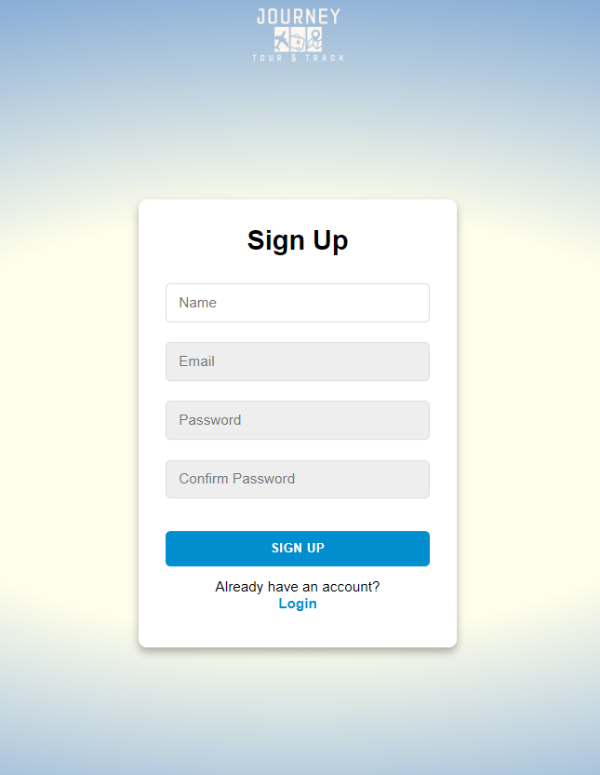

1. **Sign In:**
   * Enter your credentials on the Sign In page.

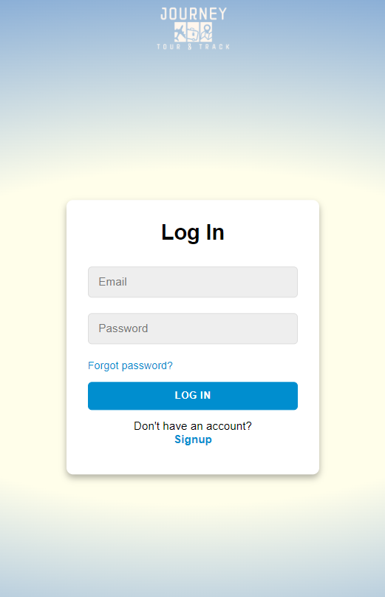

1. **Admin Dashboard:**
   * Access the admin dashboard to update tour packages, offers, and destinations.

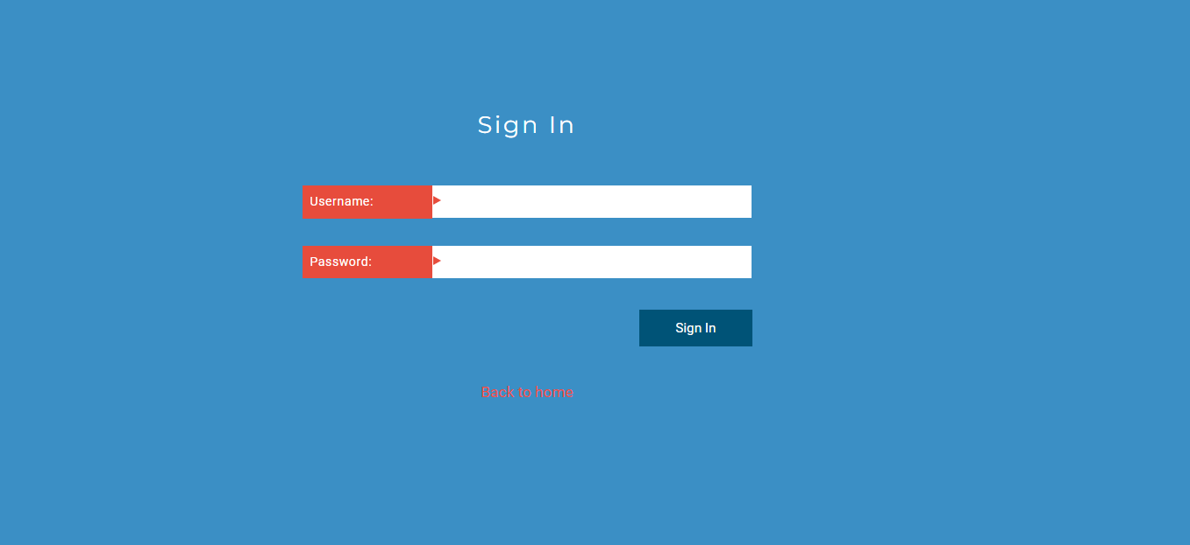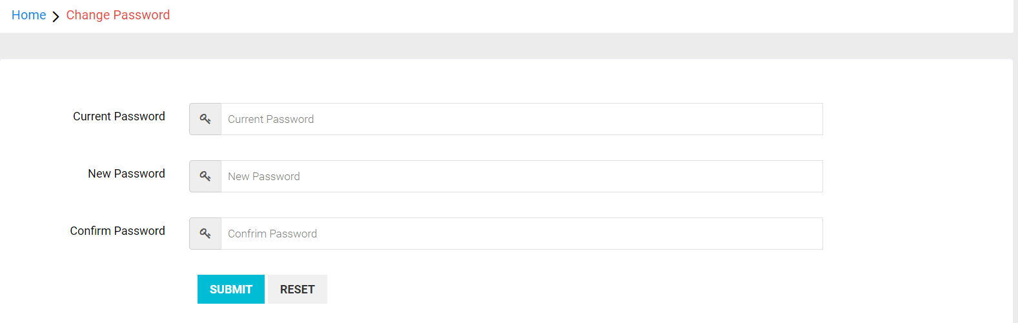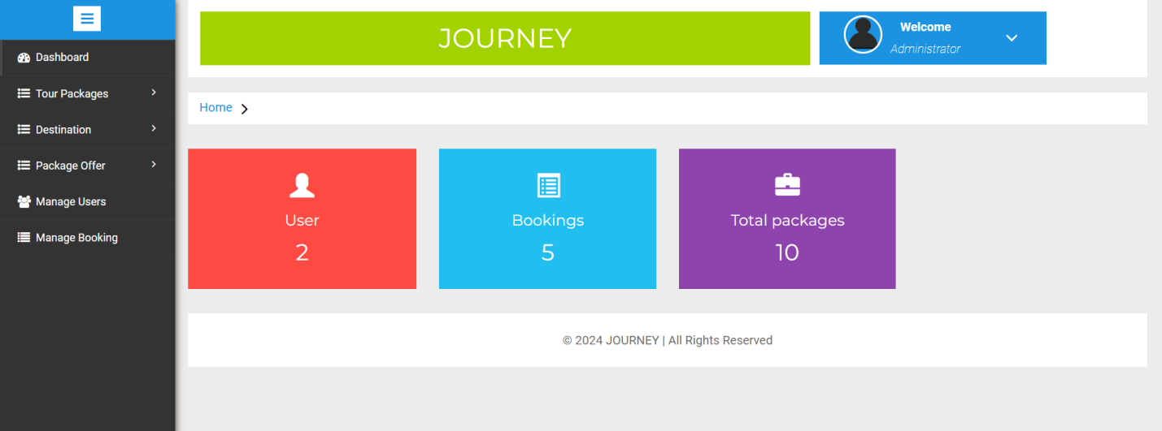

1. **Booking a Tour:**
   * Browse available tours and book your preferred package.

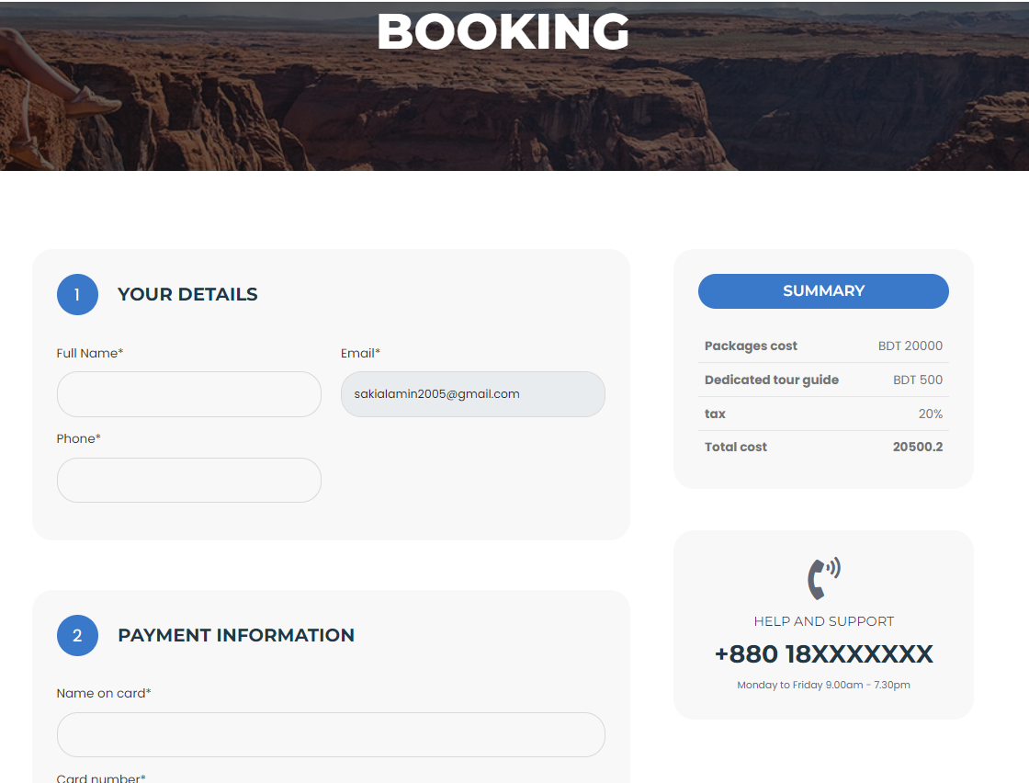

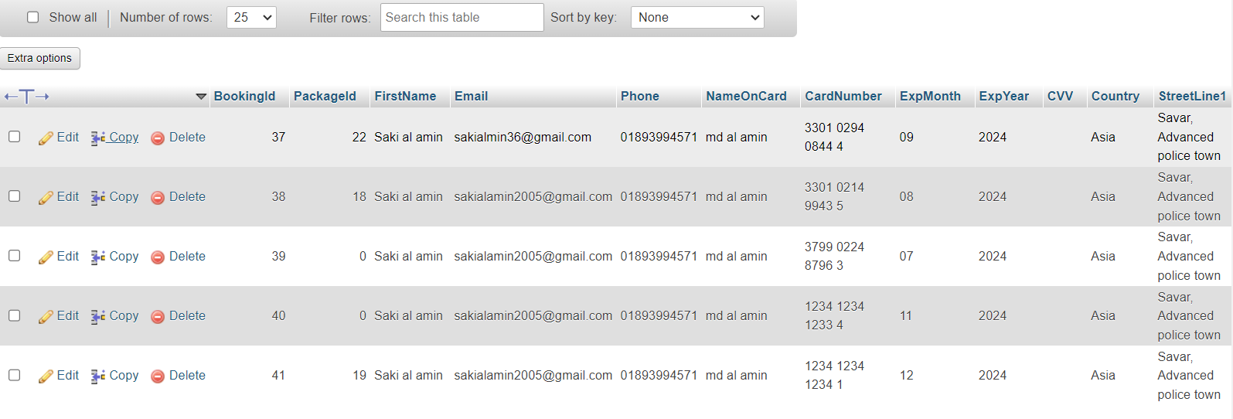

1. **User Profile:**
   * Manage your profile and view booking history.

#### 

1. **Package:**
   * Show all available packages.

